Irregular Periodic Tessellation
# Source: AI Source: Provided by: [Data Path: Persons Table -> ID Column: 1, Name_En Column: Motasem Essam] -> From: [ChatGPT] on [7/25/2026]
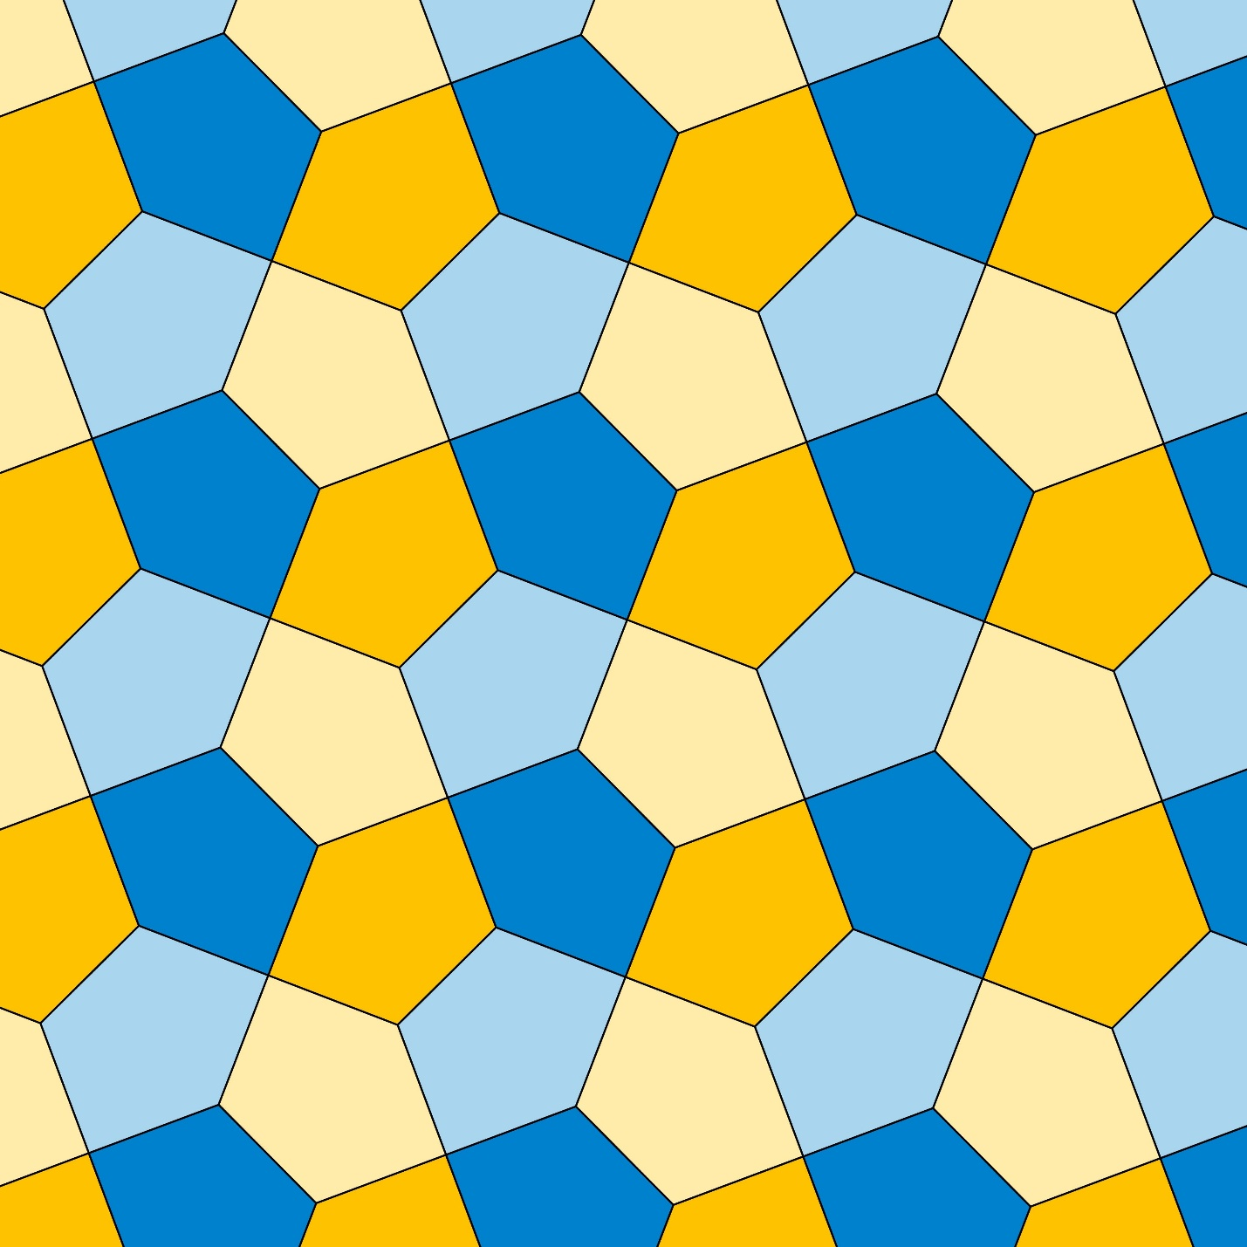
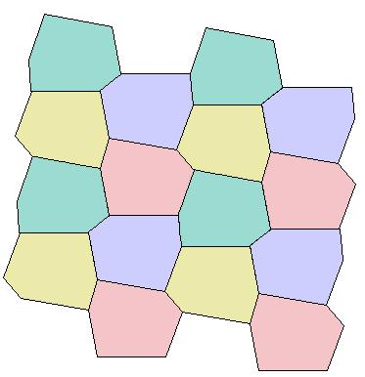
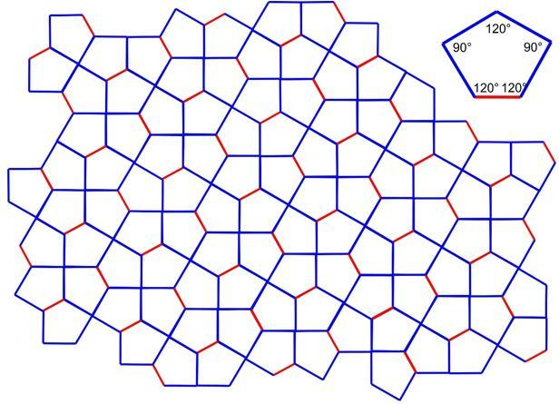
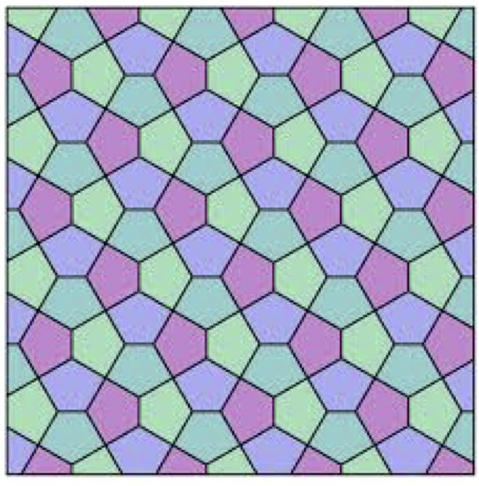
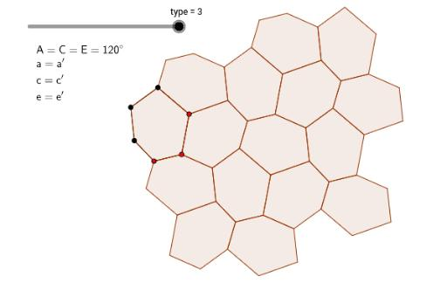

Definition
# Source: AI Source: Provided by: [Data Path: Persons Table -> ID Column: 1, Name_En Column: Motasem Essam] -> From: [ChatGPT] on [7/25/2026]
An Irregular Periodic Tessellation is a tessellation of the plane that:
- Covers the plane completely with no gaps or overlaps.
- Contains irregular polygons and/or irregular geometric arrangements.
- Does not satisfy the defining conditions of a regular or semi-regular tessellation.
- Has a repeating pattern under translation.
In other words:
Irregular describes the geometric structure, while Periodic describes the repeating symmetry of the entire tessellation.
A periodic tiling is invariant under at least one nonzero translation. (MathWorld)

Classification Position
# Source: AI Source: Provided by: [Data Path: Persons Table -> ID Column: 1, Name_En Column: Motasem Essam] -> From: [ChatGPT] on [7/25/2026]
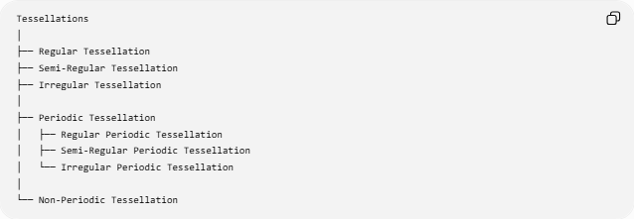
Tessellations
│
├── Regular Tessellation
├── Semi-Regular Tessellation
├── Irregular Tessellation
│
├── Periodic Tessellation
│ ├── Regular Periodic Tessellation
│ ├── Semi-Regular Periodic Tessellation
│ └── Irregular Periodic Tessellation
│
└── Non-Periodic Tessellation
Two independent properties
It is important not to interpret these as completely separate categories.
A tessellation can be classified according to both:
Geometric regularity
$$\text{Regular}→\text{Semi-Regular}→\text{Irregular}$$
and
Translational behavior
$$\text{Periodic}→\text{Non-Periodic}$$
Therefore, an irregular tessellation can still be periodic.

Fundamental Characteristics

1. Periodic repetition
# Source: AI Source: Provided by: [Data Path: Persons Table -> ID Column: 1, Name_En Column: Motasem Essam] -> From: [ChatGPT] on [7/25/2026]
The most important characteristic is that some nonzero translation reproduces the tessellation.
Conceptually:
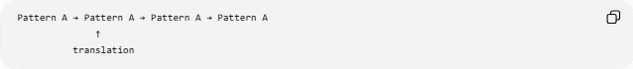
Pattern A → Pattern A → Pattern A → Pattern A
↑
translation
A fundamental region or repeating unit can be translated repeatedly to reproduce the entire pattern.

2. Irregular geometric structure
# Source: AI Source: Provided by: [Data Path: Persons Table -> ID Column: 1, Name_En Column: Motasem Essam] -> From: [ChatGPT] on [7/25/2026]
Unlike a regular tessellation, the tiles do not have to be regular polygons.
For example, an irregular periodic tessellation may contain:
- Irregular triangles
- Irregular quadrilaterals
- Irregular pentagons
- Irregular hexagons
- Other polygonal tiles
There are many possible tilings using irregular polygons. For example, mathematical classifications of tilings include multiple tilings by identical convex irregular polygons. (MathWorld)

3. No requirement for one vertex configuration
# Source: AI Source: Provided by: [Data Path: Persons Table -> ID Column: 1, Name_En Column: Motasem Essam] -> From: [ChatGPT] on [7/25/2026]
A semi-regular tessellation requires the same polygon sequence around every vertex.
An irregular periodic tessellation does not require this.
For example:
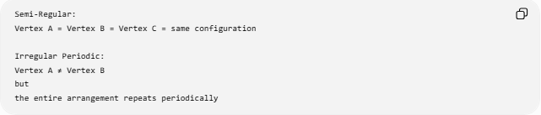
Semi-Regular:
Vertex A = Vertex B = Vertex C = same configuration

Irregular Periodic:
Vertex A ≠ Vertex B
but
the entire arrangement repeats periodically
This is one of the major differences between the two categories.

Example: Cairo Tessellation
# Source: AI Source: Provided by: [Data Path: Persons Table -> ID Column: 1, Name_En Column: Motasem Essam] -> From: [ChatGPT] on [7/25/2026]
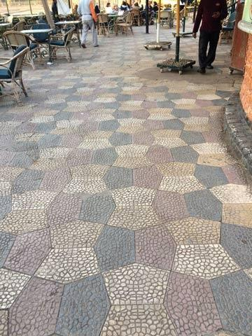
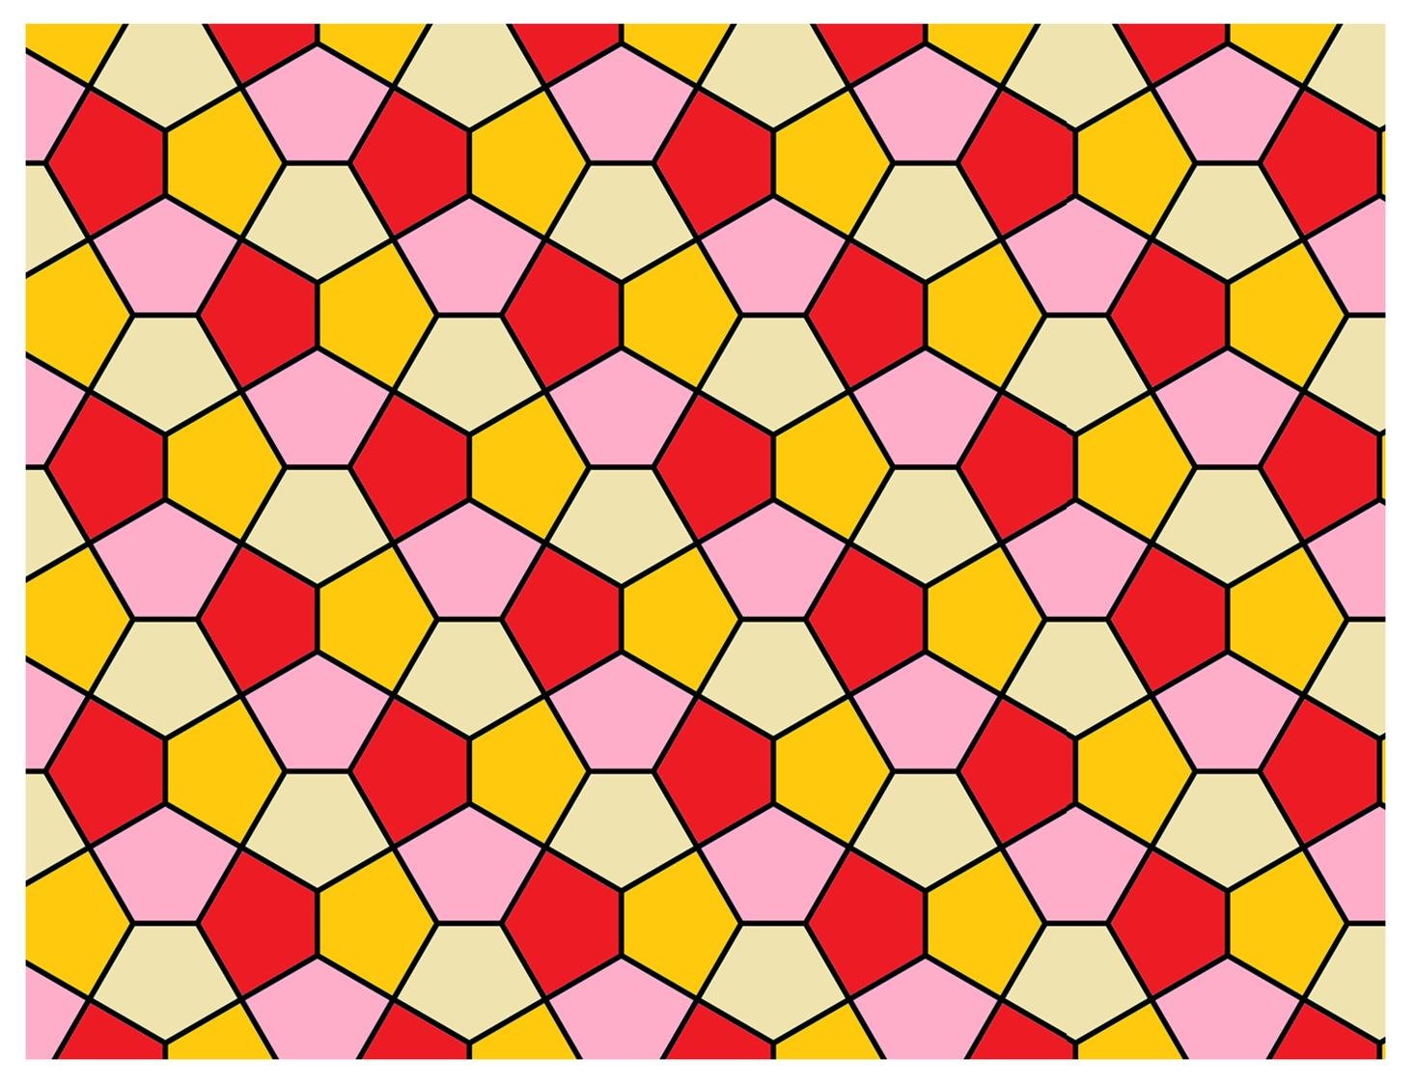
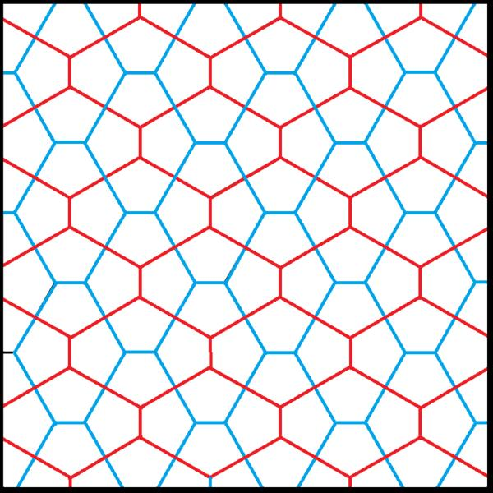
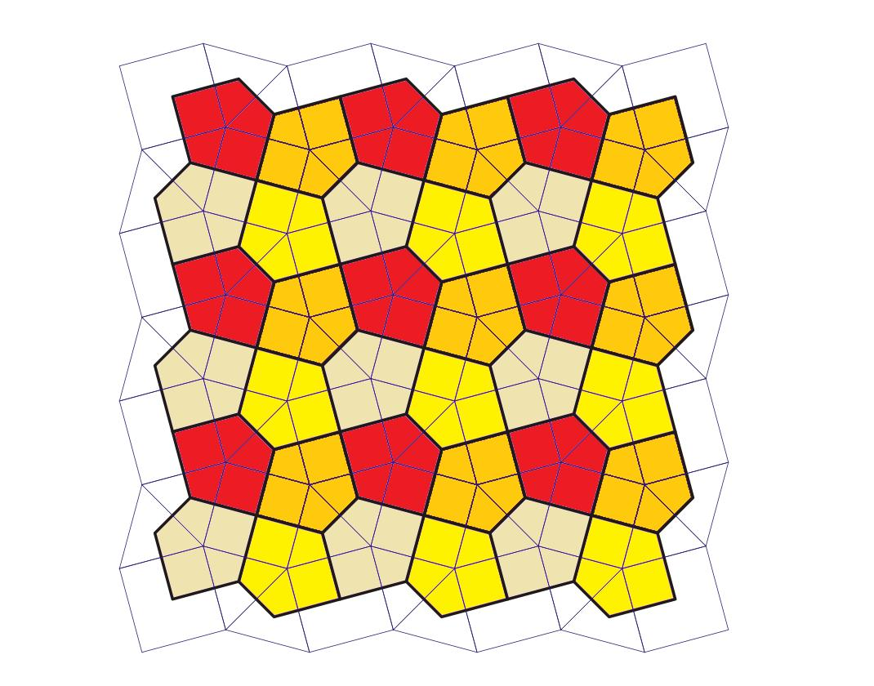
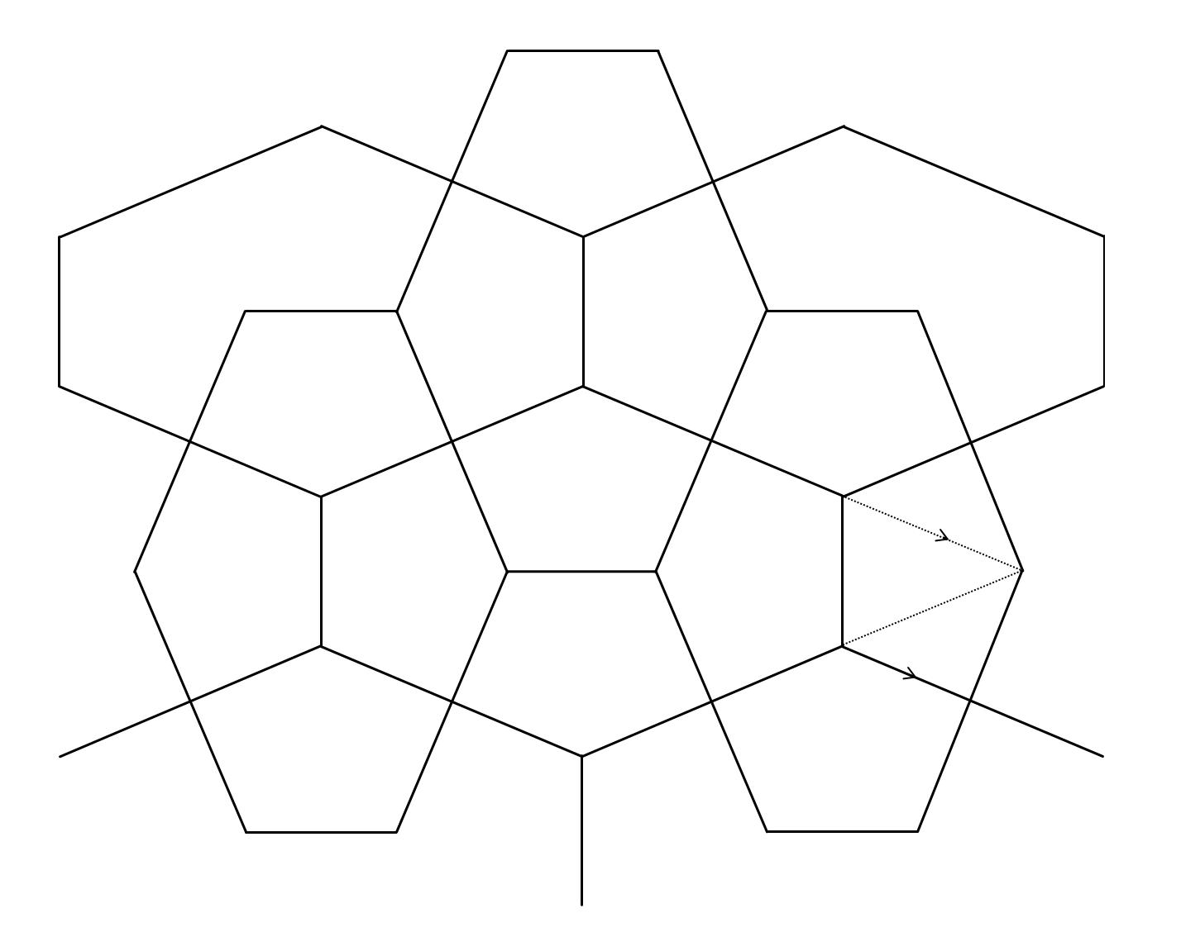
The Cairo tessellation is a useful example of a periodic tessellation involving irregular pentagonal tiles.
It appears in traditional Cairo paving and Islamic geometric decoration. Its tiles are pentagonal and the tessellation is related to the dual of the square-and-equilateral-triangle semi-regular tessellation. (MathWorld)
The important point for your classification is:
- It is a plane-filling tessellation.
- Its tiles are not regular pentagons.
- It has a repeating geometric structure.
- Therefore, it illustrates how irregular geometry can coexist with periodicity.

Example: Periodic Irregular Hexagon Tessellation
# Source: AI Source: Provided by: [Data Path: Persons Table -> ID Column: 1, Name_En Column: Motasem Essam] -> From: [ChatGPT] on [7/25/2026]
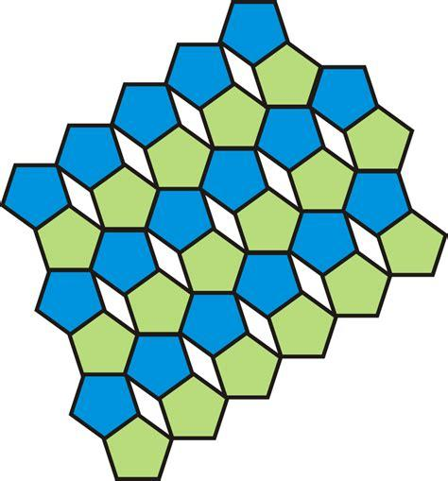
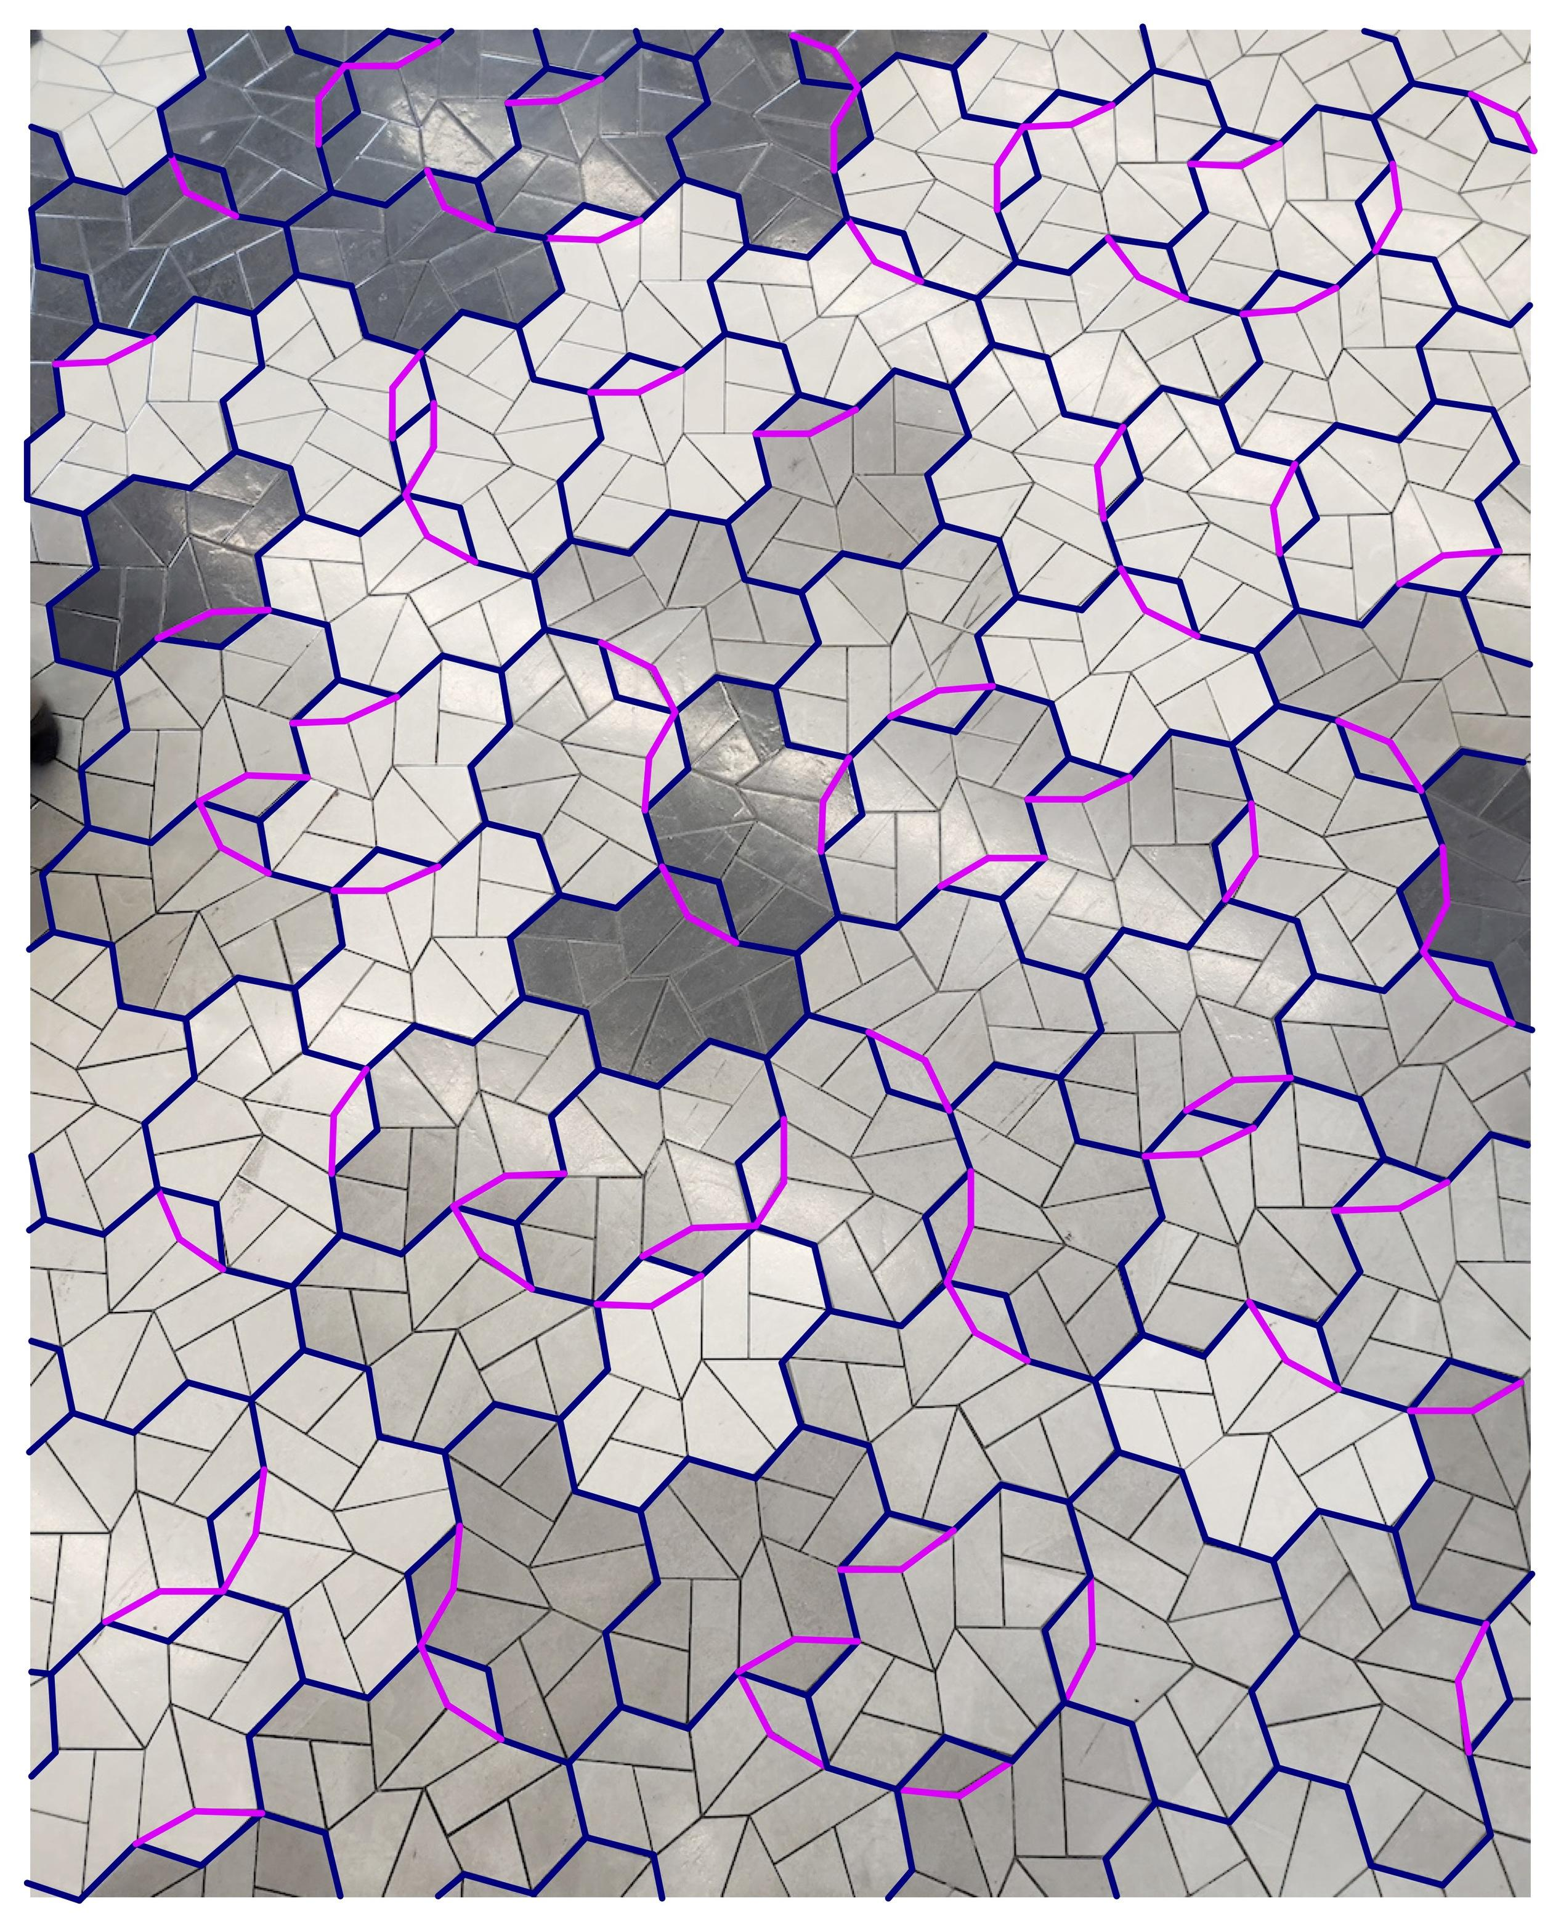
Irregular hexagons can also form periodic tessellations.
In fact, there are several known ways to tile the plane with identical irregular hexagons. The regular hexagonal tessellation is a special case within these families. (MathWorld)
This demonstrates an important principle:
A tile does not have to be regular for the resulting tessellation to be periodic.

Irregular Periodic vs Semi-Regular Periodic
# Source: AI Source: Provided by: [Data Path: Persons Table -> ID Column: 1, Name_En Column: Motasem Essam] -> From: [ChatGPT] on [7/25/2026]
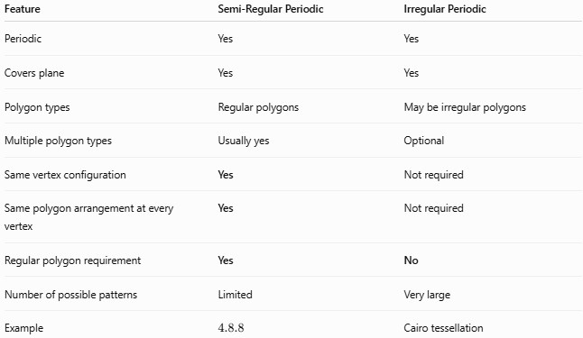
Feature | Semi-Regular Periodic | Irregular Periodic
Periodic | Yes | Yes
Covers plane | Yes | Yes
Polygon types | Regular polygons | May be irregular polygons
Multiple polygon types | Usually yes | Optional
Same vertex configuration | Yes | Not required
Same polygon arrangement at every vertex | Yes | Not required
Regular polygon requirement | Yes | No
Number of possible patterns | Limited | Very large
Example | $$4.8.8$$ | Cairo tessellation
The standard semi-regular/Archimedean tessellations specifically require convex regular polygons arranged in the same order around each vertex; there are eight mixed types in the Euclidean plane. (MathWorld)

Irregular Periodic vs Regular Periodic
# Source: AI Source: Provided by: [Data Path: Persons Table -> ID Column: 1, Name_En Column: Motasem Essam] -> From: [ChatGPT] on [7/25/2026]
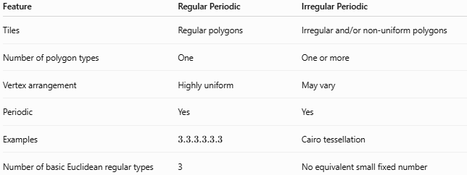
Feature | Regular Periodic | Irregular Periodic
Tiles | Regular polygons | Irregular and/or non-uniform polygons
Number of polygon types | One | One or more
Vertex arrangement | Highly uniform | May vary
Periodic | Yes | Yes
Examples | $$3.3.3.3.3.3$$ | Cairo tessellation
Number of basic Euclidean regular types | 3 | No equivalent small fixed number
There are exactly three regular tessellations of the Euclidean plane: triangles, squares, and regular hexagons. (MathWorld)

Irregular Periodic vs Non-Periodic
# Source: AI Source: Provided by: [Data Path: Persons Table -> ID Column: 1, Name_En Column: Motasem Essam] -> From: [ChatGPT] on [7/25/2026]
This distinction is particularly important.
Irregular Periodic Tessellation
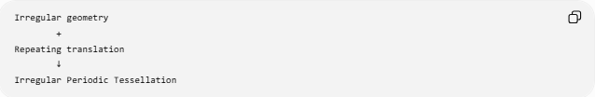
Irregular geometry
+
Repeating translation
↓
Irregular Periodic Tessellation
Irregular Non-Periodic Tessellation
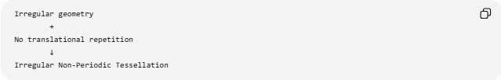
Irregular geometry
+
No translational repetition
↓
Irregular Non-Periodic Tessellation
So irregular does not tell us whether a tessellation is periodic.
Likewise, periodic does not tell us whether the tiles are regular.

Irregular Does Not Mean Random
# Source: AI Source: Provided by: [Data Path: Persons Table -> ID Column: 1, Name_En Column: Motasem Essam] -> From: [ChatGPT] on [7/25/2026]
An irregular periodic tessellation can look complicated while still having a precise repeating structure.
For example:
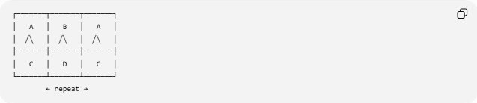
┌───────┬───────┬───────┐
│ A │ B │ A │
│ ╱╲ │ ╱╲ │ ╱╲ │
├───────┼───────┼───────┤
│ C │ D │ C │
└───────┴───────┴───────┘
← repeat →
The individual tiles may be irregular, but the overall arrangement repeats.

Important Taxonomy Note
# Source: AI Source: Provided by: [Data Path: Persons Table -> ID Column: 1, Name_En Column: Motasem Essam] -> From: [ChatGPT] on [7/25/2026]
Do not equate:
$$\text{Irregular}=\text{Non-Periodic}$$
That is incorrect.
Similarly:
$$\text{Periodic}≠\text{Regular}$$
A better classification is:
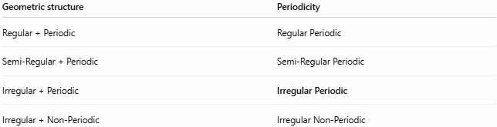
Geometric structure | Periodicity
Regular + Periodic | Regular Periodic
Semi-Regular + Periodic | Semi-Regular Periodic
Irregular + Periodic | Irregular Periodic
Irregular + Non-Periodic | Irregular Non-Periodic
Also, non-periodic and aperiodic are not always synonymous. A non-periodic tiling simply has no nonzero translational symmetry, whereas an aperiodic tiling satisfies the stronger condition that arbitrarily large periodic patches do not occur. (MathWorld)

Key Properties
# Source: AI Source: Provided by: [Data Path: Persons Table -> ID Column: 1, Name_En Column: Motasem Essam] -> From: [ChatGPT] on [7/25/2026]
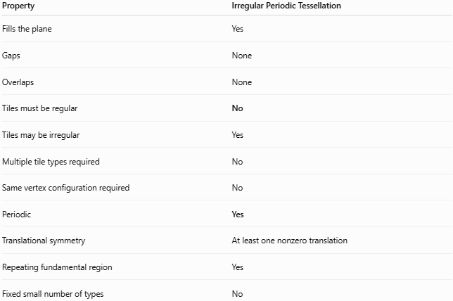
Property | Irregular Periodic Tessellation
Fills the plane | Yes
Gaps | None
Overlaps | None
Tiles must be regular | No
Tiles may be irregular | Yes
Multiple tile types required | No
Same vertex configuration required | No
Periodic | Yes
Translational symmetry | At least one nonzero translation
Repeating fundamental region | Yes
Fixed small number of types | No

Conclusion
# Source: AI Source: Provided by: [Data Path: Persons Table -> ID Column: 1, Name_En Column: Motasem Essam] -> From: [ChatGPT] on [7/25/2026]
An Irregular Periodic Tessellation is a plane-filling tessellation whose geometric structure is irregular, but whose overall pattern repeats periodically through translation.
The defining relationship is:
$$\boxed{\text{Irregular Geometry}+\text{Periodic Repetition}=\text{Irregular Periodic Tessellation}}$$
The key idea for your taxonomy is:
Regularity and periodicity are independent properties. An irregular tessellation can be periodic, and a periodic tessellation does not have to be regular.

